**Impact of transformation in the dataset**

I tried to do the following transformation on CNN model on MNIST dataset.

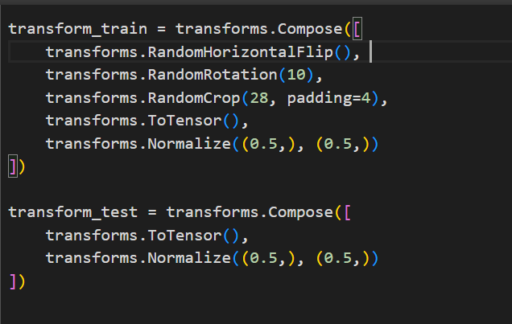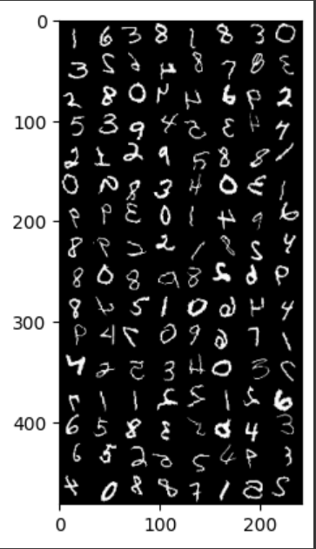 The transformed images

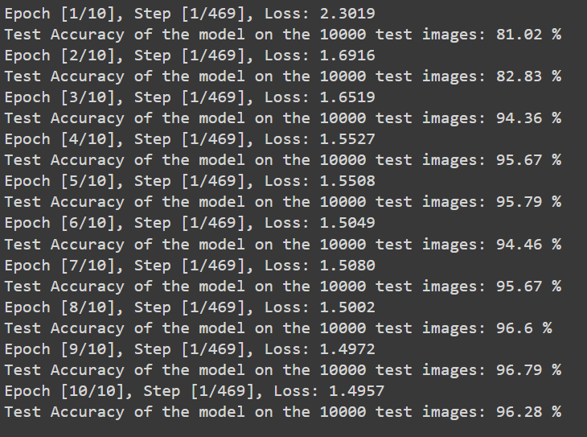

Here the results clearly depict that the accuracy of the model has gone down by 2-3% and the training time of the dataset has also increased by a large amount (almost 5 times slower that usual). Hence, I decided to drop this idea of using transformation in any further models and used a different file to show transformation implementation.

**Running model on Resnet**

I used the below model and ran it on the MNIST dataset

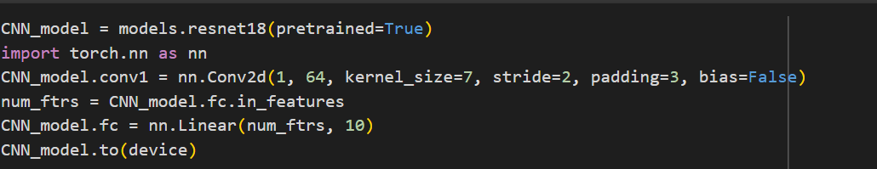

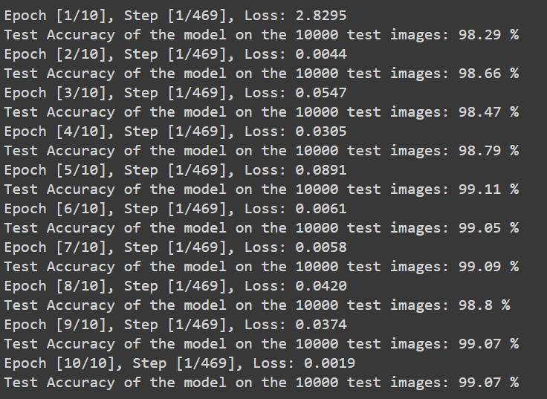 ON MNIST Dataset

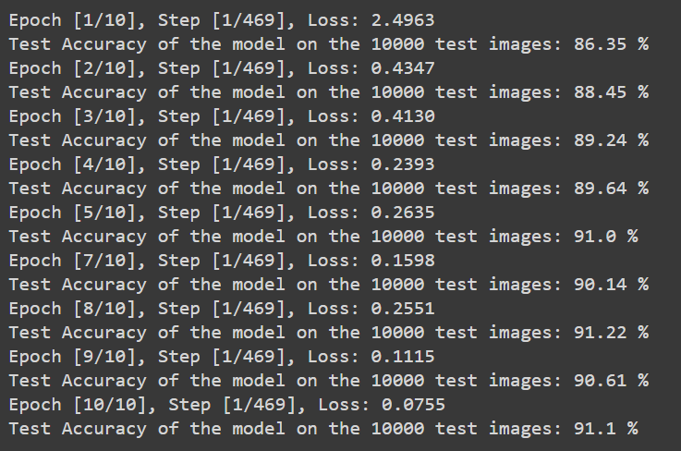 ON Fashion_MNIST Dataset

*The Results were quite good and the accuracy as well as the training time were excellent.*